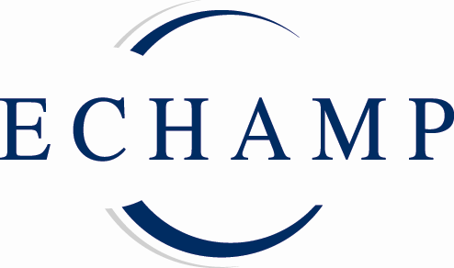

P R E S S R E L E A S E

New report in English supports effectiveness of homeopathy
Brussels 6 December 2011: A comprehensive report into the effectiveness, use, safety and cost effectiveness of homeopathy is now available in English. ‘Homeopathy in Healthcare’ presents the results of the first multi-disciplinary review (Health Technology Assessment) into homeopathy; it concludes that ‘there is sufficient evidence for the … clinical efficacy of homeopathy and for its safety and economy compared to conventional treatment.’
First carried out as part of the Swiss Programme for the Evaluation of Complementary Medicine (PEK) in 2005, this report has until now only been available to the German speaking public. Editor of the new edition, Dr Gudrun Bornhöft, welcomes the publication in English: “This report into the effectiveness of homeopathy takes a specific approach in its evaluation of the data available. The strong results in favour of the effectiveness of homeopathy, enhanced by some more recent developments, remain as valid as ever. I am delighted that this work is now available to the wider international community.”
A Health Technology Assessment has been defined as a ‘multi-disciplinary field of policy analysis that examines the medical, economic, social and ethical implications of the incremental value, diffusion and use of a medical technology in health care.’ The unique approach of this report is its emphasis on external evidence into the effectiveness of homeopathy, as well as on more traditional types of scientific studies, such as randomised controlled trials, meta-analyses or systematic reviews.
ECHAMP President, Nand De Herdt, also welcomes the new publication. “This important report provides a much needed bridge for homeopathy between the world of research and the world of decision making. This new translation will make these compelling results in favour of homeopathy more accessible to a wider range of European and national health policy makers. We hope it will re-launch discussions on the integration of scientifically proven complementary medicine approaches in mainstream healthcare policy, in line with the explicit wish of more than one hundred million EU-citizens.”

Notes for editors

- Homeopathy in Healthcare - Effectiveness, Appropriateness, Safety, Costs; Gudrun Bornhoft; Peter F. Matthiessen (Eds.), Springer 2011, ISBN 978-3-642-20637-5 €30,00 (approx.); available from 8 December at www.springer.com/medicine/complementary+%26+alternative+medicine/book/978-3-642-20637-5 (price €29,90); full text will be available to read online from January.
- Homeopathy is a long-standing European therapeutic tradition with an overall positive safety record; it enjoys continuous growth in popularity with patients, doctors and practitioners; three out of four Europeans know about homeopathy and of these 29% use it for their own healthcare.
- Homeopathic medicinal products are low risk, mostly derived from natural substances and usually highly diluted; thousands of these products have been safely on the market in Europe for many decades. However, patients, doctors, practitioners and industry have issues with the current legal and regulatory framework because it is inappropriate for the specific nature of these products, resulting in a serious lack of availability for users and for prescribers.
- ECHAMP, the European Coalition on Homeopathic and Anthroposophic Medicinal Products, represents the industry for homeopathic and anthroposophic medicinal products in Europe. ECHAMP’s aim is to achieve full availability of homeopathic and anthroposophic medicinal products in the EU.

Press enquiries
For further information, please contact:
Per Engström on 00 32 2 649 94 40 - media@echamp.eu
Amandine Oset on 00 32 2 649 94 40 - media@echamp.eu

