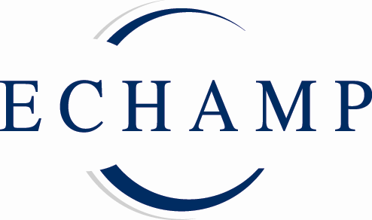

P R E S S R E L E A S E
More EU investment needed for research in homeopathy and anthroposophic medicine

Brussels 13 April 2011 MEPs, experts and stakeholders meeting at the European Parliament in Brussels today called on the European Commission to give greater priority to research into complementary medicine, including homeopathy and anthroposophic medicine, in future EU research programmes.

The meeting, ‘Homeopathy and Anthroposophic Medicine – what is the evidence?’, chaired by Marian Harkin MEP, examined the evidence base for these well established and widely used European therapeutic systems. The debate was timed to coincide with the Commission’s Green Paper on a Common Strategic Framework for future EU Research and Innovation Funding, which plans to move ahead with proposing specific programmes before the end of the year.
Mrs Harkin spoke of the needs of more than 100 million users of these products across Europe: “The fast growing demand for homeopathy and anthroposophic medicine stems from many years of successful practical experience, coupled with the excellent overall safety profile of these therapeutic approaches and their medicinal products. The EU should act now in support of these long-established European therapies to the benefit of more than 100 million European patients and users,” she said.

Speaking at the meeting, Robert Mathie PhD, Research Development Adviser at the British Homeopathic Association, made a convincing case for the need for further research in homeopathy: “Homeopathy is a complex medical intervention whose diffuse research literature contains positive evidence of clinical effectiveness in over 40% of studies to date. The quality of that evidence and the size of the treatment effects are not clearly defined, however. New insights offer a sharper focus on the necessity, the opportunities and the challenges of further research development,” he concluded.

Clinical evidence in anthroposophic medicine, based on the daily work of a hospital, was presented by Dr.med. Harald Matthes, Medical Director at the Havelhöhe Hospital in Berlin, which specialises in anthroposophic medicine and was chosen as the best hospital in Germany in a patient survey of 2000 hospitals in 2008. Dr Matthes described anthroposophic medicine as an independent holistic medicine system that considers the multidimensionality of the human being (psychic, mental and spiritual) and develops specific scientific methods of diagnosis and therapy. “Anthroposophic medicine is a valid approach of integrative medicine as defined by the World Health Organisation. It is not a closed system, but a researching and scientific medicine system, a continuously developing medicine concept,” he said.

The meeting concluded that homeopathy and anthroposophic medicine should be integrated into EU health policy and research programmes for the benefit of European citizens as part of a more integrated and holistic approach to health care in Europe.

Notes for editors

- Homeopathy is a long-standing European therapeutic tradition with an overall positive safety record; it enjoys continuous growth in popularity with patients, doctors and practitioners; three out of four Europeans know about homeopathy and of these 29% use it for their own healthcare.
- Anthroposophic medicine is practised by more than 4000 anthroposophic doctors in 21 EU Member States, Norway, Switzerland, Russia and Croatia. It is regularly taught at universities and medical schools in 7 EU Member States and Switzerland. It is provided in 24 hospitals in 5 EU Member States and Switzerland.
- Homeopathic and anthroposophic medicinal products are low risk, mostly derived from natural substances and usually highly diluted; thousands of these products have been safely on the market in Europe for many decades. However, patients, doctors, practitioners and industry have issues with the current legal and regulatory framework because it is inappropriate for the specific nature of these products, resulting in a serious lack of availability for users and for prescribers.

- The meeting celebrated World Homeopathy Awareness Week; it was organised in co-operation with ECHAMP, the European Coalition on Homeopathic and Anthroposophic Medicinal Products, which represents the vast majority of the industry for these products in Europe. ECHAMP’s main aim is an appropriate legal and regulatory framework in order to achieve free and easy availability of these medicinal products in the EU. www.echamp.eu

Press enquiries
For further information, please contact:
Per Engström on 00 32 2 649 94 40 - media@echamp.eu
Amandine Oset on 00 32 2 649 94 40 - media@echamp.eu

