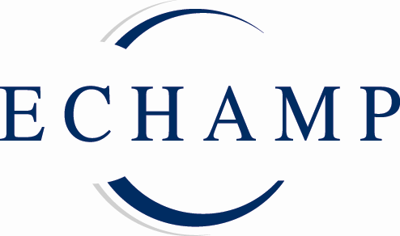
P R E S S R E L E A S E
EU industry for homeopathic and anthroposophic medicinal products exceeds €1 billion for third year in a row
Brussels 15 December 2011: A new study values the total EU market for homeopathic and anthroposophic medicinal products in 2010 at €1.035 billion, showing that the EU industry for these products exceeded the €1 billion mark for the third year in a row.
‘Homeopathy and anthroposophic medicine in the EU: Facts and Figures 2011’ (Third edition), published by ECHAMP, the European Coalition on Homeopathic and Anthroposophic Medicinal Products, demonstrates significant growth in the sales of homeopathic and anthroposophic medicinal products over the past fifteen years. It shows continued good growth for many markets in 2010, especially the smaller ones, but nevertheless the overall picture for the EU in 2010 is one of a slight decline.
As far back as 1997, the European Commission reported that three out of four Europeans know about homeopathy, and of these 29% use it for their own health care. Manufacturers experience consistently high and increasing demand for these products from patients and practitioners.
Nevertheless these new figures demonstrate a clear contradiction between the high demand for homeopathic and anthroposophic medicinal products and the actual product sales: ECHAMP President, Nand De Herdt, explains: “Disproportionate provisions in the EU legal and regulatory framework, and the slow and deficient implementation and enforcement in the Member States are putting an excessive administrative and economic burden on the manufacturers, resulting in reduced availability of these medicinal products. In a number of markets, manufacturers are unable to meet the strong demand from patients and practitioners for these products.”
Last published in 2007, the updated ‘Facts and Figures 2011’ presents a unique summary of the situation for homeopathic and anthroposophic medicinal products in the EU. It presents detailed market data, information on the legal status of the products, and individual country profiles, clearly demonstrating the long-standing tradition and deep roots of both homeopathy and anthroposophic medicine in Europe.
Says Nand De Herdt, “European and national policy makers can no longer ignore the importance of these therapeutic systems to patients and practitioners alike. We sincerely hope that this new profile of the sector will prompt them to find better solutions to make these products more easily available.”

Notes for editors

- Sales of homeopathic and anthroposophic medicinal products in the EU (1995-2010)
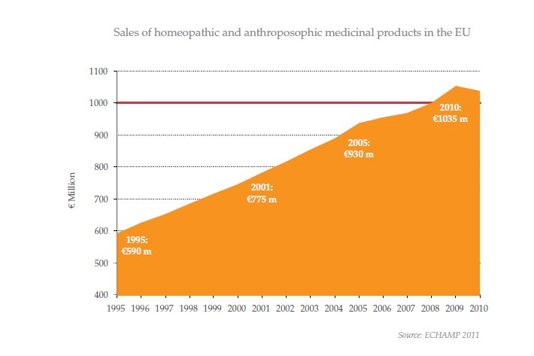
- ‘Homeopathy and anthroposophic medicine in the EU: Facts and Figures 2011’ (Third edition), ECHAMP, December 2011, Price €25,00
- Homeopathic and anthroposophic medicinal products are low risk, mostly derived from natural substances and usually highly diluted; thousands of these products have been safely on the market in Europe for many decades. They adhere to the highest pharmaceutical quality standards.
- Homeopathy enjoys continuous growth in popularity with patients, doctors and practitioners; three out of four Europeans know about homeopathy and of these 29% use it for their own healthcare (Commission Report COM 97 362 (final)).
- Anthroposophic medicine is practised by more than 4000 anthroposophic doctors in 21 EU Member States. It is taught at universities and medical schools in 7 EU Member States and Switzerland. It is provided in 24 hospitals in 5 EU Member States and Switzerland.
- ECHAMP, the European Coalition on Homeopathic and Anthroposophic Medicinal Products, represents the industry for homeopathic and anthroposophic medicinal products in Europe. Its aim is to achieve full availability of homeopathic and anthroposophic medicinal products in the EU.www.echamp.eu

Press enquiries
For a copy of ‘Facts &Figures’, or for any further information please contact:
Per Engström on 00 32 2 649 94 40 - media@echamp.eu
Amandine Oset on 00 32 2 649 94 40 - media@echamp.eu

